CS 255 System Design Document Template

UML Diagrams

UML Use Case Diagram
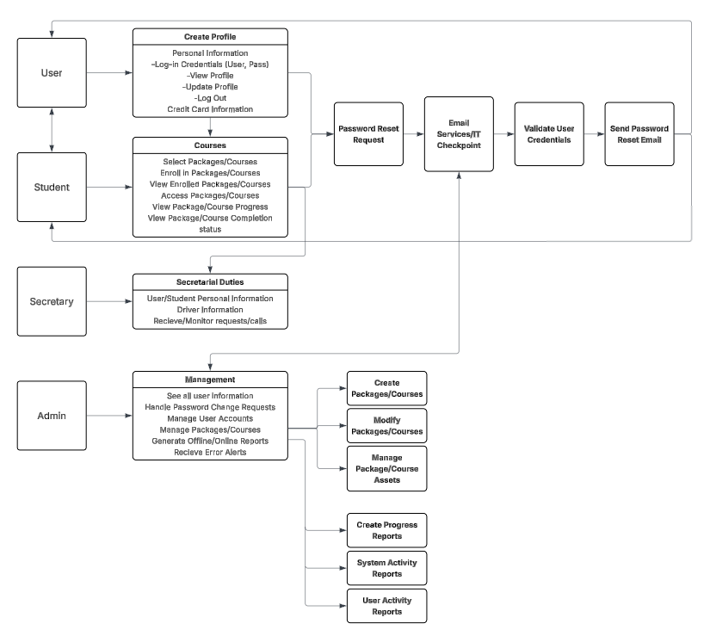

UML Activity Diagrams

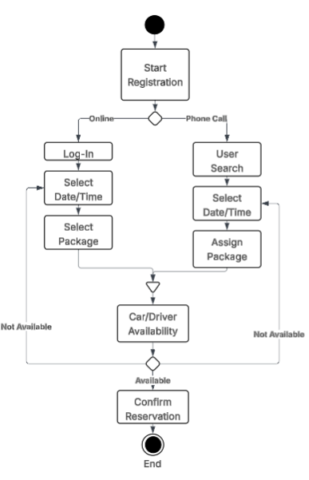
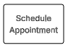
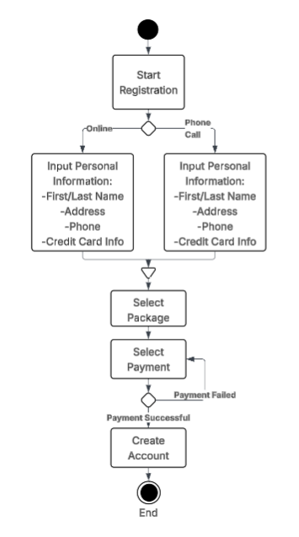

Register Customer Schedule Appointment

UML Sequence Diagram
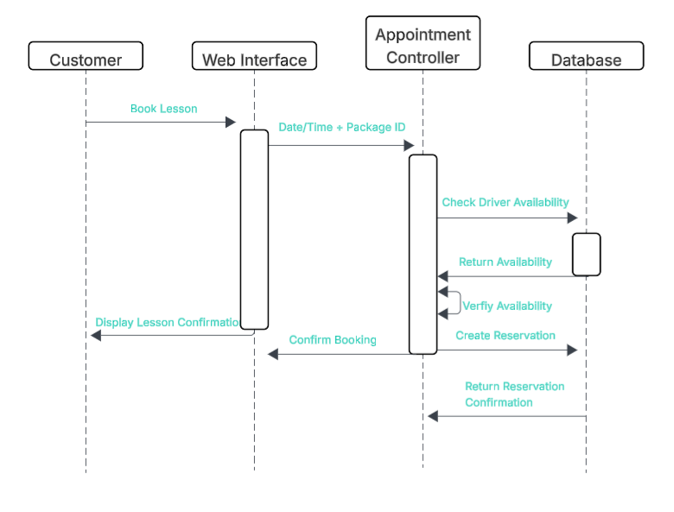
Schedule Driving Appointment

UML Class Diagram
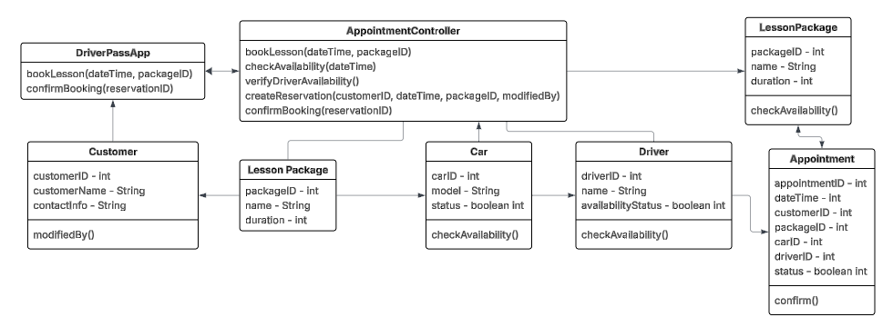

Technical Requirements
Technical requirements can be broken down into a few categories, those being the required hardware, software, tools, and infrastructure that is necessary for our systems design. I will break these categories down into bullet points for easier digestibility.
- Hardware:
- Cloud Servers: Specifically asked for to handle security and database
- Storage: We need to have a scalable storage device, so probably cloud to start out with
- Networking: Equipment for in-office work, IT team, secretary, etc.
- Software:
- Operating Systems: As we are creating a web application, we need to make sure that the application can run on any OS.
- Database Management: Something to help manage out databases, i.e. MySQL
- IDE: Something to code our web application with
- Tools:
- API: Something that can help us integrate the changes that the DMV makes into our program smoothly and swiftly.
- Payment management: We will need to use a payment gateway to accept payment from customers.
- Version control: Using something like Git will allow us to push new updates and track modifications.
- Infrastructure:
- Cloud hosting: The owner, Liam, specifically requested to be able to edit work from anywhere, offline or online. Being able to push changes once back online.

